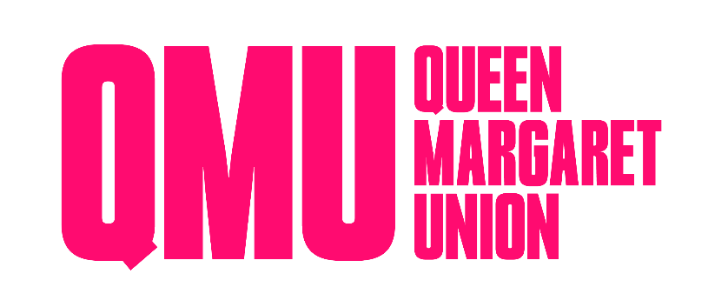
MINUTES OF EMERGENCY GENERAL MEETING
9th October 2025
2PM- Games Room and Hybrid

Sederunt
Martin Aasterud, Lorcan Adams, Callum Bloomfield, Harry Bruce, Christian Burns, Lauren Clark, Abigail Close, Ryan Davey, Felix Foreman Mackenzie, Joy Gilmour, Eve Grintet, Charlotte Henry, Molly Harris, Eva Jafari, Gregor Kelman, Jasmine Lambert, Harry Leadingham, Niamh Matthews, Eva Melone, Rose Miller, Hannah Macmillian, Jason Macmillan, Mia McMaster, Adam Meek, Isla Manning, Grace Munro, James Munro, Charlotte Newell, Louise Nugent, Izzy O’Farrell, Adam Paterson, Ailsa Peebles, Jamie Pritchard, Bee Pritchard, Gwion Rhisiart, Urja Singh, James Smith, James Smith, Georgie Small, Lucy Stobie, Craig Stout, Abbie Sutton, Tamsin Surtees, Fiona Whitely, Lucy Widdows, Bex Williamson.
Minutes
Comments | Actions
LS: In reference to the current 2021 copy of the constitution with 2023 amendments. If these proposed 2025 amendments pass, we will be adding these amendments to the constitution, to be sent to university court.  Right now the board of management consists of a Campaigns Convenor, Events Convenor, Publications Convenor, Social Convenor, Tech Convenor and Welfare Convenor.  These proposed amendments will add Communications Convenor and a Convenor of Current Student Representatives.  These will both be student-elect positions. They will be beneficial to the QMU as a charity for its outreach, as well as the smooth running of the board.  Yes or no vote to pass. Raise hands.  Unanimously yes in person.  Unanimously yes online. | LS Proposed constitutional amendments  Amendments pass unanimously.  New positions are now constitutional.

