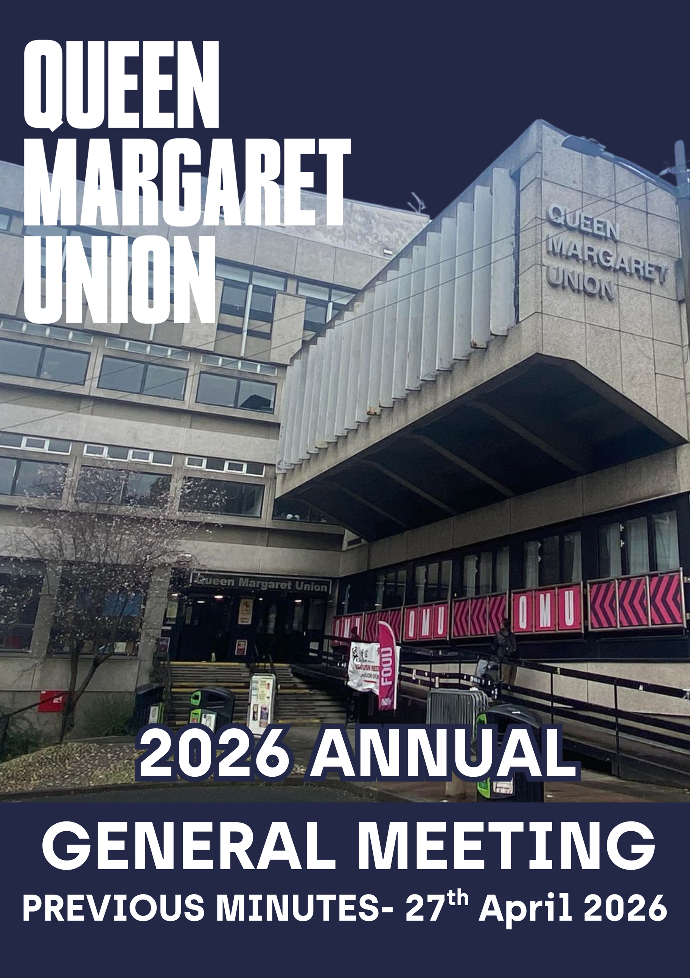

Minutes of the Queen Margaret Union Annual General Meeting 2025-26
(27th April 2026, 2pm)
- Sederunt
M Davidson, L Stobie, U Singh, L Tolland, M Harris, B O’Donnell, I Sigerson, C Henry, J Gilmour, G Munro, D Blair, S McCabe, K Kurth, P Harvey, M McMaster, B Muir, J Smith, A Paterson, M Matthews, C Newell, I Dhar, J Munro, E Callen, L Nugent, J Pritchard, A Meek, A Murad

- Apologies
G Rhisiart, G Small
- Additional agenda items
Nothing to add

- Minutes from the last Annual General Meeting
Passed by all

- 2025-26 Finance Report of the Honorary Treasurer
BO’D: Provides an overview of how QMU is doing from a commercial point of view, in terms of university funding, grants, and the general trading environment.

BO’D: Noted that the Union had achieved a record year of turnover and had recorded a surplus for the year, compared with a loss in the previous year.

BO’D: Further noted that the loss of income from room rentals would have a significant impact on the Union’s finances in the coming year, and that work was ongoing to address this shortfall.

B O’D: Highlighted that prices would likely need to increase in the coming year due to rising costs. Bills had trebled overall, and the Union’s status as a Living Wage employer also brought significant additional costs.

- Passing of the Reports of the Board of Management

6.1. Report of President
Nothing to add to report.

6.2. Report of Vice President Board of Management
Nothing to add to report.

6.3. Report of Vice President Memberships, Clubs, and Societies
Nothing to add to report.

6.4 Report of the Campaigns Convenor
Nothing to add to report.

6.5 Report of Communications Convenor
Nothing to add to report.

6.6. Report of CSR Convenor
Nothing to add to report.

6.7. Report of the Events Convenor
Nothing to add to report.
6.8. Report of the Publications Convenor
SM : Reports that the spring issue has been released and is doing well

6.9. Report of the Social Convenor
Nothing to add to report.

6.10 Report of the Tech Convenor
Nothing to add to report.

6.11 Report of the Welfare Convenor
Nothing to add to report.

The reports of the Board of Management were approved unanimously.

- Announcement of election of President, Vice President (Membership, Clubs and Societies) and Vice President (Board of Management)
President: Urja Singh
Vice President Membership, Clubs, and Societies: Molly Harris
Vice President Board of Management: Patrick Harvey

- Announcement of election of Board of Management

Campaigns Convenor: CJ Adebayo Omoaka
Events Convenor: James Munro
Publications Convenor: Daisy Blair
Social Convenor: Christian Burns
Tech Convenor: Matthew Matthews
Communications Convenor: Mia McMaster
Current Student Representatives A:
Haider Aboloushi, Georgie Small, James Smith, Ishika Dhar

Current Student Representatives B:
Ben Muir, Adam Murad, Rachel Young
Former Student Member: Martin Aasterud

- Nomination and Election of Honorary Vice Presidents

US: Appoints Ellie Power and Archie Dodd

Passed by all

- Nomination and Election of Honorary President
LS: Suggests the possibility of Emily Sande as she is a life member and has an honorary doctorate from Glasgow University
LS: Highlights that she will need to be contacted to do this so will be revisited

- Auditors
LS: Proposes WDM Chartered Accountants be reappointed as the QMU’s auditors
Passed by all

- Bank
LS: Proposes the Royal Bank of Scotland reapproval as the QMU’s Bank
Passed by all

MD: Expresses that this may be something we are looking to change and if proposed will be brought to an EGM

- Nomination and Election of Honorary Life Members

AP: Proposes Jamie Kelly
Passed by all

HA: Proposes CupcakKe
Passed by all

US: Proposes Fraser Rundell
Passed by all

PH: Proposes Molly Mitchell
Passed by all

US: Proposes Adzii Boii
Passed by all

- AOCB
Nothing to add
Meeting adjourned by L Stobie 15:35

